1. Implemented features / Completed Work and Design Decisions
In this sprint, our primary goal was Requirements Engineering and Data Collection.
- User Research: We successfully defined three key personas and conducted interviews to validate our assumptions. Based on the interview feedback , specifically regarding the "tourist" persona's fear of getting lost, we made a design decision to implement a "Hover" feature on the map markers for quick information access, distinguishing it from the "Click" action for detailed status.
- Project Planning & Design: We completed the User Stories, finalized the UI Mockups, and defined the acceptance criteria to guide future testing.
- Technical Infrastructure: We set up the MySQL database and successfully developed Python scraping scripts for both JCDecaux (Bikes) and OpenWeather (Weather) APIs.
- Design Decision on Data: We decided to set the bike scraper interval to 5 minutes. This decision balances data granularity with API rate limits and storage efficiency. The scrapers are currently running and populating the database.

2. Burndown chart of sprint 1
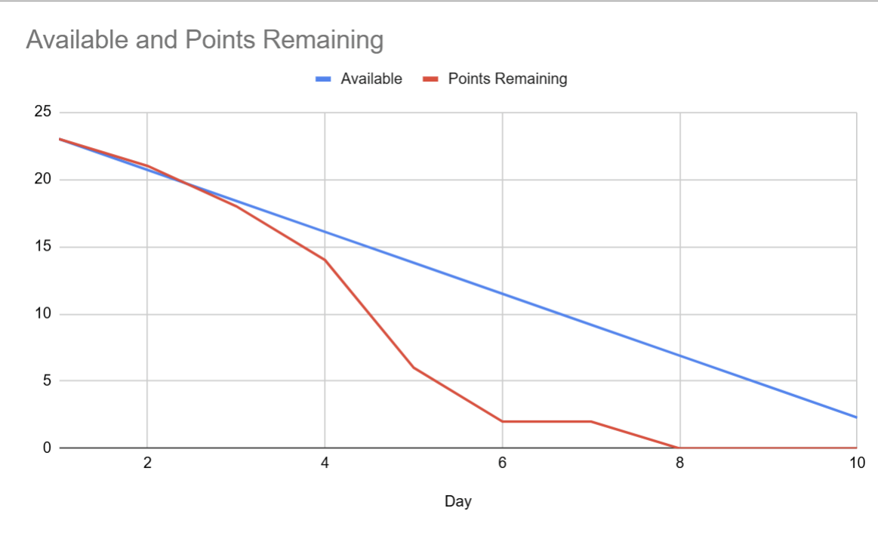
The Burndown chart shows a steep decline in remaining effort. Our "Actual Remaining Effort" line dropped below the "Ideal Trend" line around Day 4, indicating that the team worked faster than anticipated. We reached zero remaining tasks 2 days before the sprint deadline. This high velocity allowed us to dedicate the remaining time to backlog refinement and researching the feasibility of optional features.

3. Sprint Review
- Mockup Walkthrough: Presented the Figma/PDF mockups, explaining how the UI solves the specific pain points of our personas.
- Data Verification: Showed the live MySQL database tables with rows of real-time data collected over the past few days, proving the stability of our scrapers.
- Scope Discussion: Since we finished early, we raised a discussion regarding the "Smart Journey Planner" feature. We are currently evaluating if adding this complex feature fits within our remaining timeline. We agreed to finalize this decision in the next Sprint Planning.

4. Sprint Retrospective
What went well:
Our team successfully established a communication channel on Discord for daily updates. Crucially, we conducted user interviews to validate our three key personas (Student, Professional, Tourist). These real-world insights were invaluable, specifically highlighting the "tourist" need for intuitive navigation and weather prediction, which directly influenced our decision to prioritize map interactivity in the design phase. Furthermore, the web scraping scripts for JCDecaux and OpenWeather APIs were not only developed ahead of schedule but have been running stably. This early success is significant as it ensures our database is consistently populated, providing a reliable foundation that will make our upcoming integration and development phases much smoother.

What could be improved:
Some team members were initially unfamiliar with the mechanics of sending API requests and configuring the local MySQL database environment, which took extra time to research and troubleshoot. However, we successfully finished all tasks in the end. Next time, we will help each other more to solve technical issues faster.

For next sprint:
Backend Integration: We will shift focus to setting up the Flask application and connecting it to the database.
Visualization: The main goal is to get the scraped data displaying on a live map interface to pass the "Real-time" acceptance criteria.
Scope Definition: We will conclude the feasibility study on the "Journey Planner" feature and decide whether to include it in the Product Backlog.

